**TITLE**:

To create an application in ownCloud to display file versions.

**ABSTRACT:**

OwnCloud supports simple version control system for files. Versioning creates backups of files which are accessible via the Versions tab on the Details sidebar. This tab contains the history of the file where you can roll back a file to any previous version. Changes made at intervals greater than two minutes are saved in data/[user]/versions.The Versions app expires old file versions automatically to ensure that users don’t exceed their storage quotas.The versions are adjusted along this pattern every time a new version is created.

**INTRODUCTION:**

ownCloud is a self-hosted file sync and share server. It provides access to your data through a web interface, sync clients or WebDAV while providing a platform to view, sync and share across devices easily — all under your control. ownCloud’s open architecture is extensible via a simple but powerful API for applications and plugins and it works with any storage. It is a suite of client-server software for creating file hosting services and using them. OwnCloud is functionally very similar to the widely used Dropbox, with the primary functional difference being that Owncloud is free and open-source, and thereby allowing anyone to install and operate it without charge on a private server. It also supports extensions that allow it to work like Google Drive, with online document editing, calendar and contact synchronization, and more. Its openness eschews enforced quotas on storage space or the number of connected clients, instead having hard limits (like on storage space or number of users) defined only by the physical capabilities of the server.

ownCloud is open source file sync and share software for everyone from individuals operating the free ownCloud Server edition, to large enterprises and service providers operating the ownCloud Enterprise Subscription. ownCloud provides a safe, secure, and compliant file synchronization and sharing solution on servers that you control.

One can share one or more files and folders on a computer, and synchronize them with his/her ownCloud server. Place files in local shared directories, and those files are immediately synchronized to the server and to other devices using the ownCloud Desktop Sync Client, Android app, or iOS app

In order for desktop machines to synchronize files with their ownCloud server, desktop clients are available for PCs running Windows, OS X, FreeBSD or Linux. Mobile clients exist for iOS and Android devices. Files and other data (such as calendars, contacts or bookmarks) can also be accessed, managed, and uploaded using a web browser without any additional software. Any updates to the file system are pushed to all computers and mobile devices connected to a user's account.

The Owncloud server is written in the PHP and JavaScript scripting languages. For remote access, it employs sabre/dav, an open-source WebDAV server. ownCloud is designed to work with several database management systems, including SQLite, MariaDB, MySQL, Oracle Database, and PostgreSQL.

OwnCloud server is available in three editions:- The free community-supported Server- this is the core server for all edition, The Standard Subscription for customers who want paid support for the core Server, without Enterprise applications and The Enterprise Subscription provides paid support for the Enterprise Edition. This includes the core Server and Enterprise apps.

Owncloud 9.0 includes features like File tagging, and filtering by tags. (Accessing your Files Using the ownCloud Web Interface), See all re-shares on files you have shared, Auto-fill user and group names while creating Federation shares (Using Federation Shares), Shared comments on files, Video player and many more.

OwnCloud can also be accessed via an android application. The ownCloud Android app offers some advantages over the Web interface viz. A simplified interface that fits nicely on a tablet or smartphone, Automatic synchronization of your files, Share files with other ownCloud users and groups, and create public share links, Instant uploads of photos or videos recorded on your Android device, Easily add files from your device to ownCloud and Two-factor authentication

The parameters control the Versions app are : 'versions_retention_obligation' => 'auto', in config.php.

If the versions app is enabled (default), this setting defines the policy for when versions will be permanently deleted.

The app also allows for two settings, a minimum time for version retention, and a maximum time for version retention. Minimum time is the number of days a version will be kept, after which it may be deleted. Maximum time is the number of days at which it is guaranteed to be deleted. Both minimum and maximum times can be set together to explicitly define version deletion.

Available values:

*auto*

default setting. Automatically expire versions according to expire rules. Please refer to Files_versions online documentation for more info.

*D, auto*

keep versions at least for D days, apply expire rules to all versions that are older than D days

*auto, D*

delete all versions that are older than D days automatically, delete other versions according to expire rules

*D1, D2*

keep versions for at least D1 days and delete when exceeds D2 days

*disabled*

versions auto clean disabled, versions will be kept forever

**IMPLEMENTATION DETAILS:**

<?php

//print_r(stat('/var/www/owncloud/data/student/files_versions/abc.txt.v1490934494'));

$i = 0;

$dir = '/var/www/owncloud/data/student/files_versions/';

if ($handle = opendir($dir)) {

while (($file = readdir($handle)) !== false){

if (!in_array($file, array('.', '..')) && !is_dir($dir.$file))

$i++;

}

$n= $i-1;

//echo $n;

}

// prints out how many were in the directory

echo "There are $i versions";

echo "<br>";

$files = array();

if ($dir) {

//echo $dir;

// loop through all of the files

$handle = opendir($dir);

//for($j=$n;$j>=0;$j--) {

if(false !== ($file = readdir($handle))){

if (!in_array($file, array('.', '..')) && !is_dir($dir.$file)) {

if(is_file($dir.'/'.$file) && is_readable($dir.'/'.$file)){

$files[$n] = $file;}

//echo $files[$n];

}}}

//$stat = stat('/var/www/owncloud/data/student/files_versions/abc.txt.v1490938665');

//echo 'Access time: ' . $stat['atime'];

// echo "$filename was last modified: " . date ("F d Y H:i:s.", $stat['atime'])."<br>";

if($n>=0)

{

// Open a directory, and read its contents

if (is_dir($dir)){

if ($dh = opendir($dir)){

while(($files[$n] = readdir($dh)) !== false){

$stat = stat($files[$n]);

//echo 'Access time: ' . $stat['atime'];

//echo "$filename was last modified: " . date ("F d Y H:i:s.", $stat['atime'])."<br>";

echo "filename:" . $files[$n] . "<br>";

$stat = stat('/var/www/owncloud/data/student/files_versions/'.$files[$n]);

echo "was last accessed: " . date ("F d Y H:i:s.", $stat['atime'])."<br>";

echo "$filename was last modified: " . date ("F d Y H:i:s.", $stat['mtime'])."<br>";

// echo "$filename was last modified: " . date ("F d Y H:i:s.", filemtime($files[$n]))."<br>";

//echo "$filename was last accessed: " . date("F d Y H:i:s.", fileatime($files[$n])). "<br>";

}

closedir($dh);

}}

/*$filename = '/var/www/owncloud/data/student/files_versions/abc.txt.v1490938665';

if (file_exists($filename)) {

echo "$filename was last modified: " . date ("F d Y H:i:s.", filemtime($filename));

}

$filename = '/var/www/owncloud/data/student/files_versions/abc.txt.v1490934494';

if (file_exists($filename)) {

echo "$filename was last accessed: " . date("F d Y H:i:s.", fileatime($filename));

}*/

$n=$n-1;

}

?

**RESULT:**

File versioning application was created. The app shows all the file versions of the files uploaded on the ownCloud user account. The last accessed and last modified details of the file can also be found. The app also successfully adds any new file’s version and displays it. The older versions are retained, however, up to 10 days. Post that the older versions of the file(s) are deleted. This limit can be changed as per the user’s requirements. The following snap shows the display of the file versioning app.

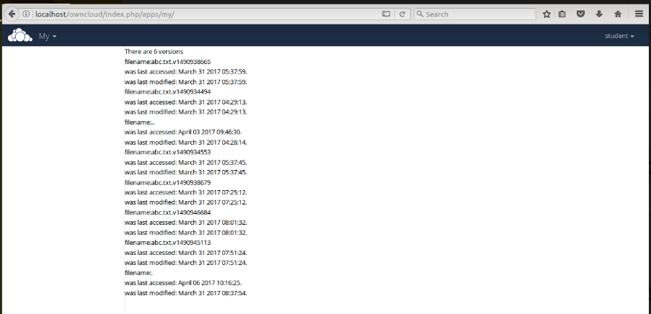

**SNAPSHOTS:**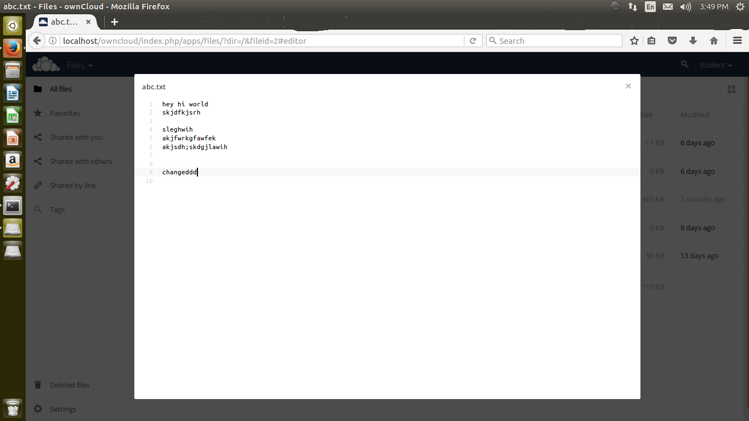

Fig. 1 Accessing a file from owncloud

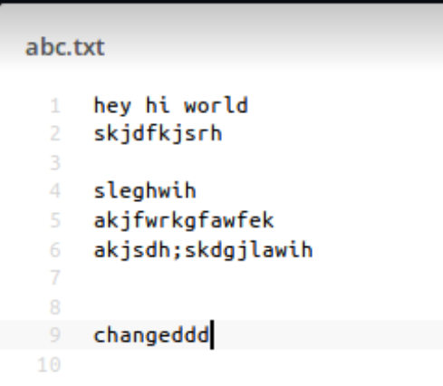

Fig. 2 Contents of file abc.txt

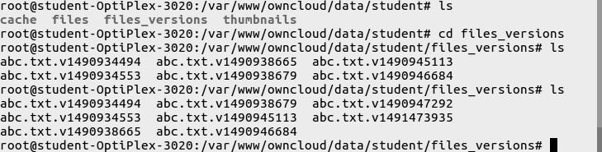

Fig. 3: Checking for the versions of file from terminal

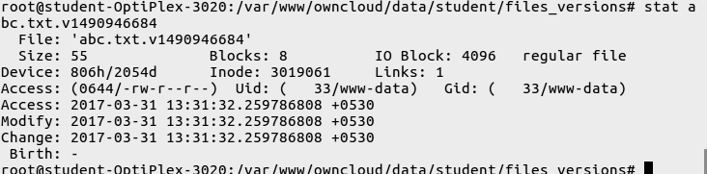

Fig. 4: Finding the details of file in terminal using stat command



Fig. 5: Details of a file viewed from ownCloud

**CONCLUSION:**

The installation and setup of ownCloud was done successfully. An application for the display of file versions was successfully created on ownCloud.

**REFERENCES:**

<https://doc.owncloud.org/>

<https://www.digitalocean.com/community/tutorials/how-to-install-linux-apache-mysql-php-lamp-stack-on-ubuntu>

<https://en.wikipedia.org/wiki/OwnCloud>

<https://www.digitalocean.com/community/tutorials/how-to-install-and-configure-owncloud-on-ubuntu-16-04>